CREW Social Media Calendar 04/13-05/13

4/13 | We formally invite you to the Seneca Falls Revisited Virtual Conference launching on Thursday, July 23rd #SenecaFallsRevisited (This will be broke up into six posts)
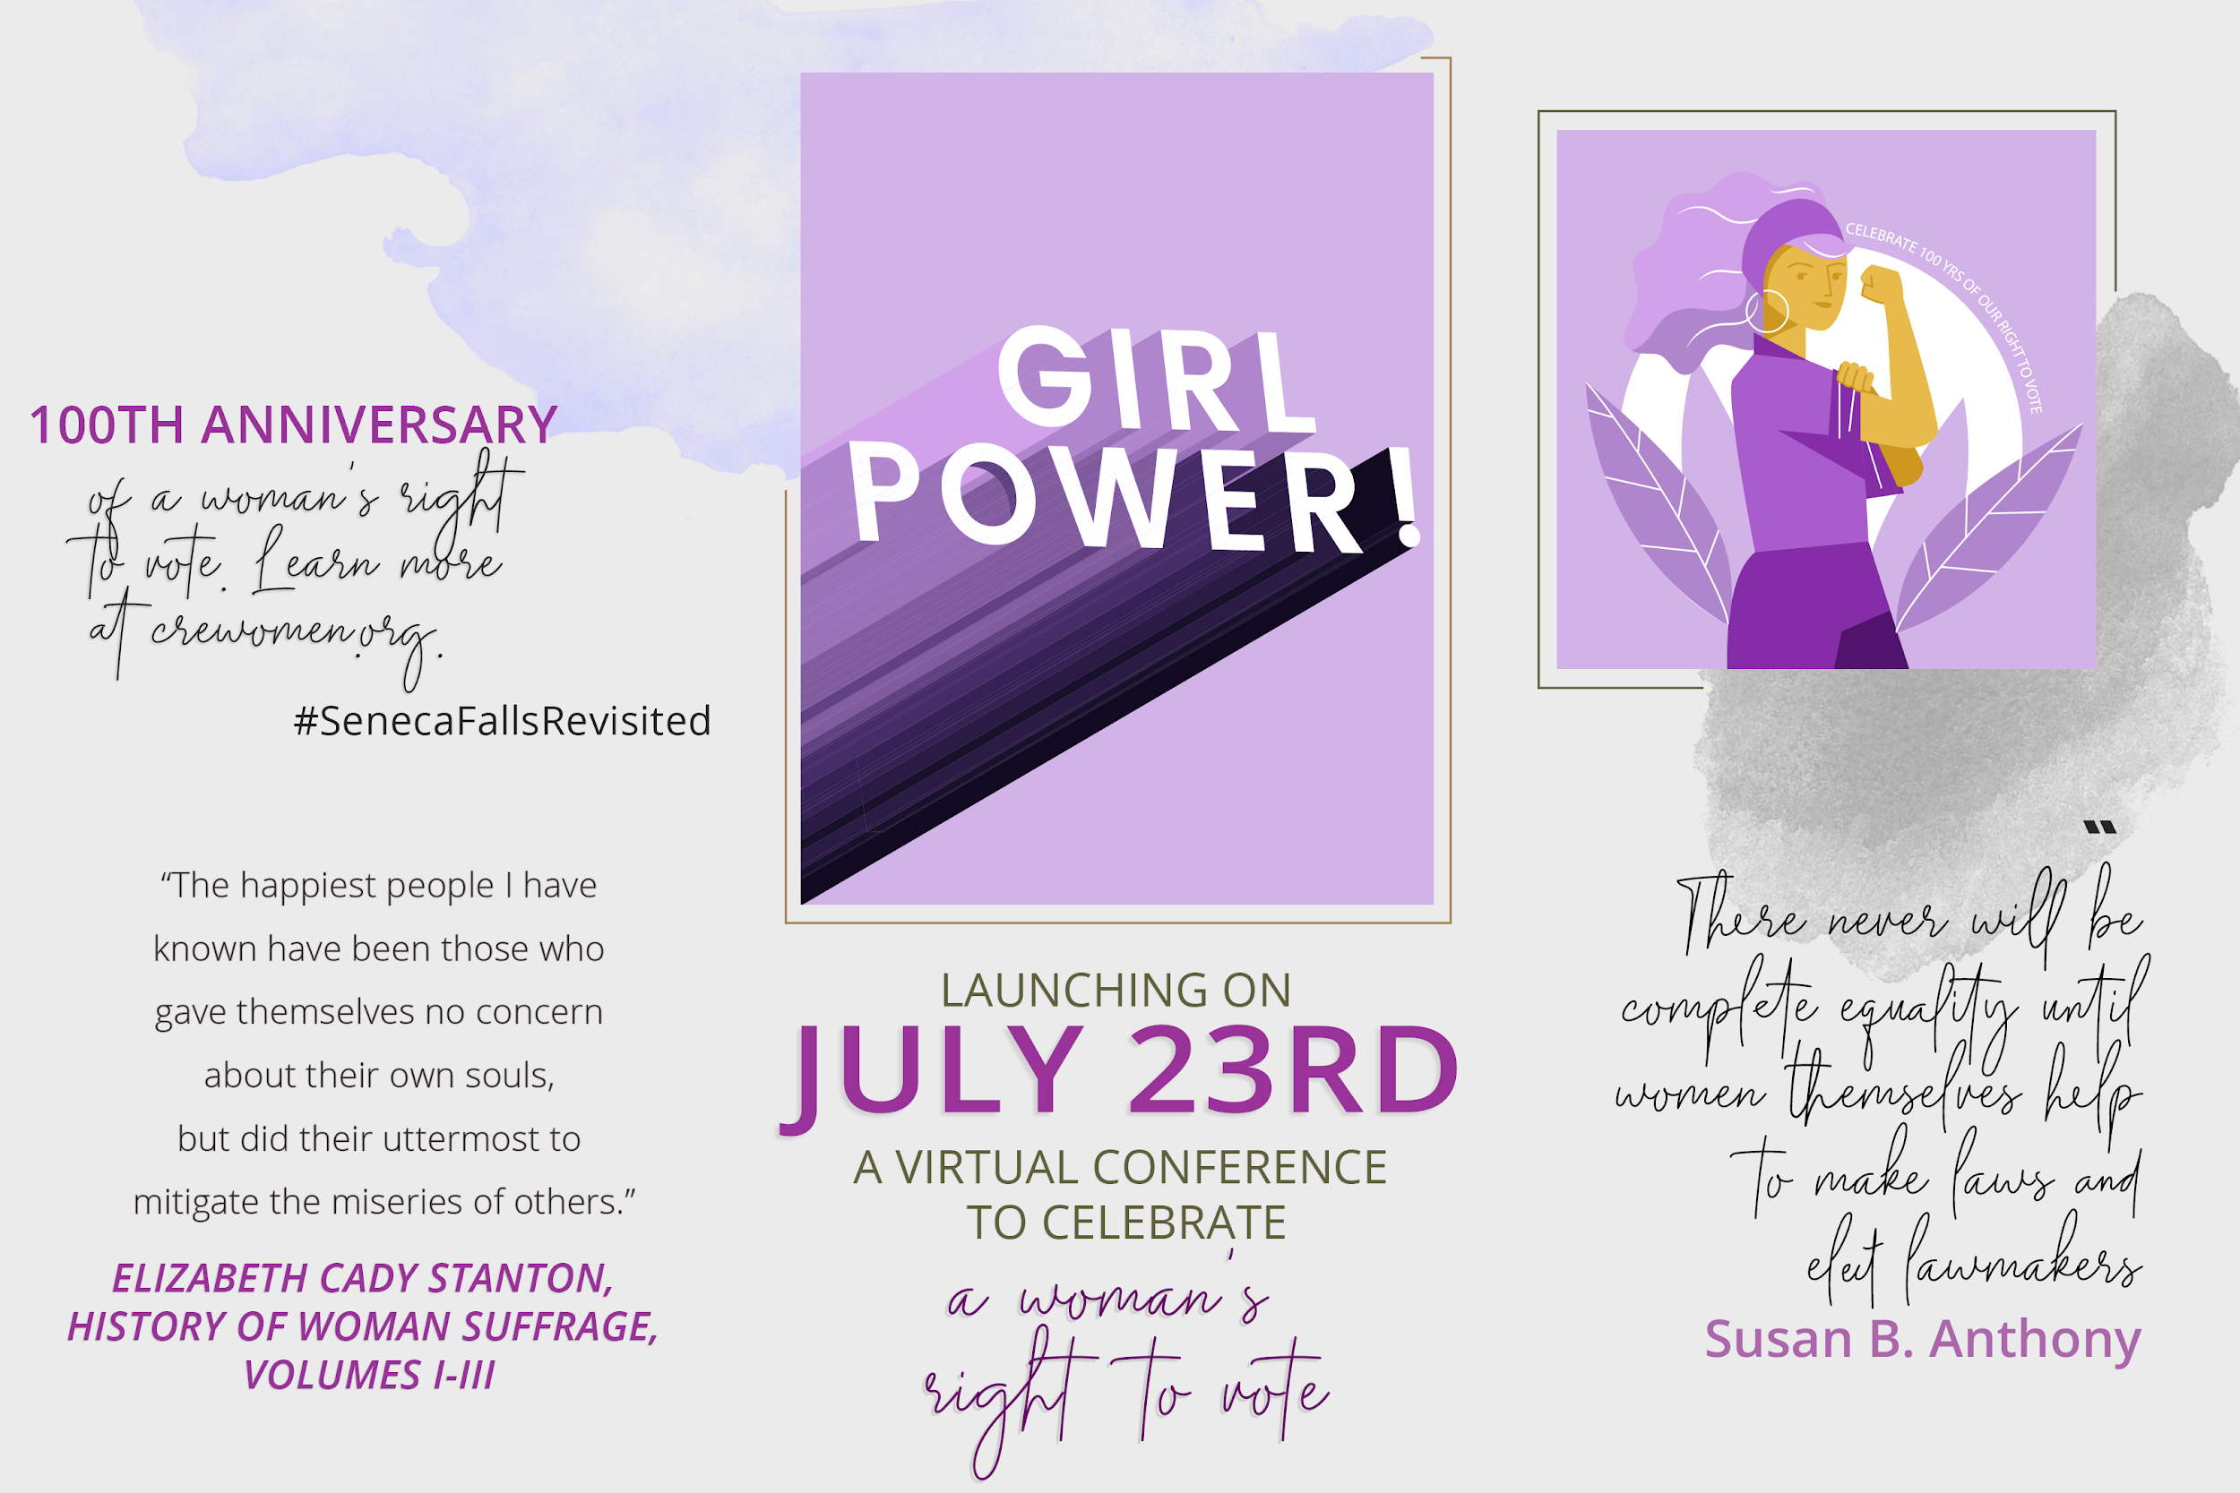

4/14 | Our first #SHEroesOfNY is @JaniraOberlin. Janira Obregon was diagnosed with Cerebral Palsy and Spastic Quadriplegia, a disability that affects my four limbs, due to a brain injury at birth. There are people who think that she needs special accommodations because of her disability, but she has not let her diagnosis slow her down. Janiara has proved to everyone that if you set your mind to it, you can accomplish anything. Last year, she modeled for the very first time in New York Fashion Week at the Fashion Revolution Event for Runway of Dreams, an organization that advocates and helps promote people with disabilities in the fashion industry. Janira Obregon believes that with perseverance and a grateful heart we can overcome any challenges and find the good in everything.
.
If you have someone you would like to nominate to be featured as one of our #SHEroesOfNY, send us a DM with their story, name, and a picture of them.
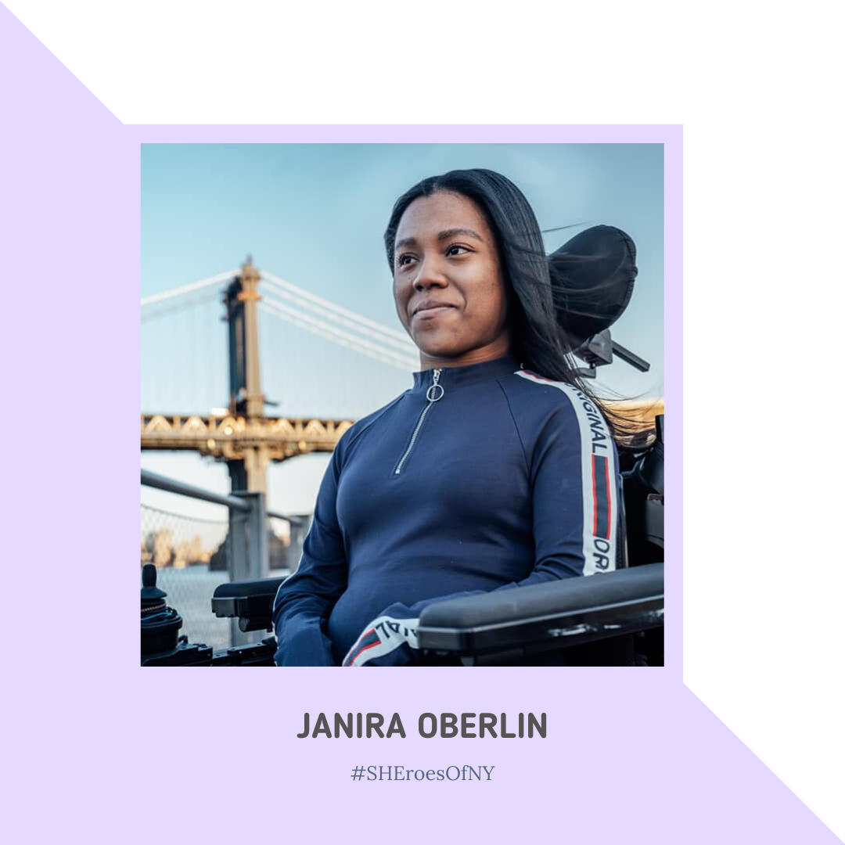

4/15 | "If particular care and attention is not paid to the ladies, we are determined to foment a rebellion, and will not hold ourselves bound by any laws in which we have no voice or representation." ― Abigail Adams
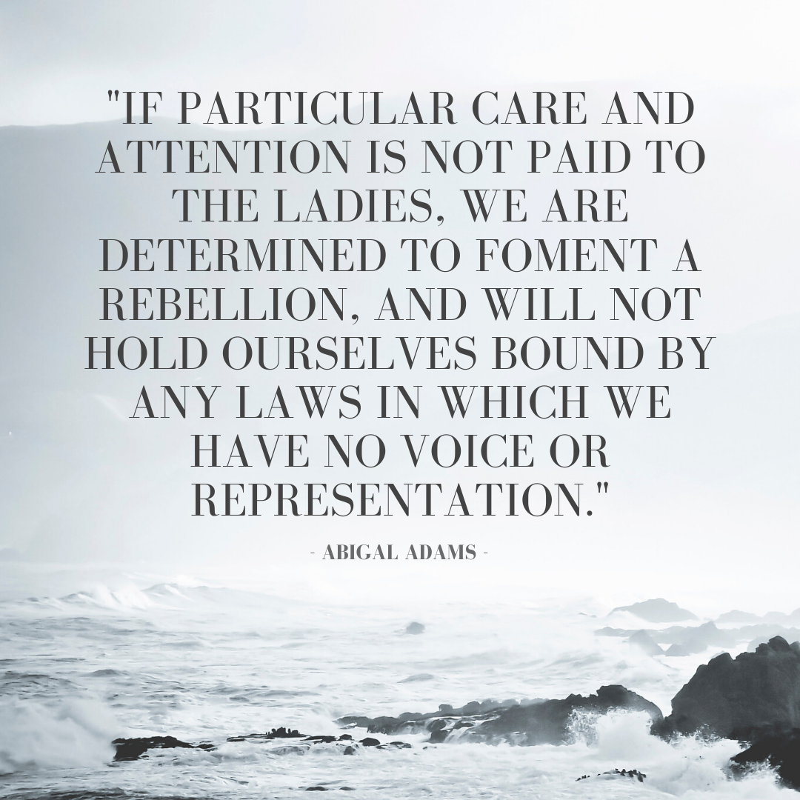

4/16 | Hannah Hart is very outspoken about mental health issues and speaks about political issues quite a bit. She has been involved in political outrage and encouraging people to vote. Hart has also led an initiative entitled “Have a Hart Day” where people gather to “spread service and reckless optimism all over the world.”
.
If you know someone you would like to nominate to be featured as one of our #SHEroesOfNY, send us a DM with their story, name, and a picture of them.
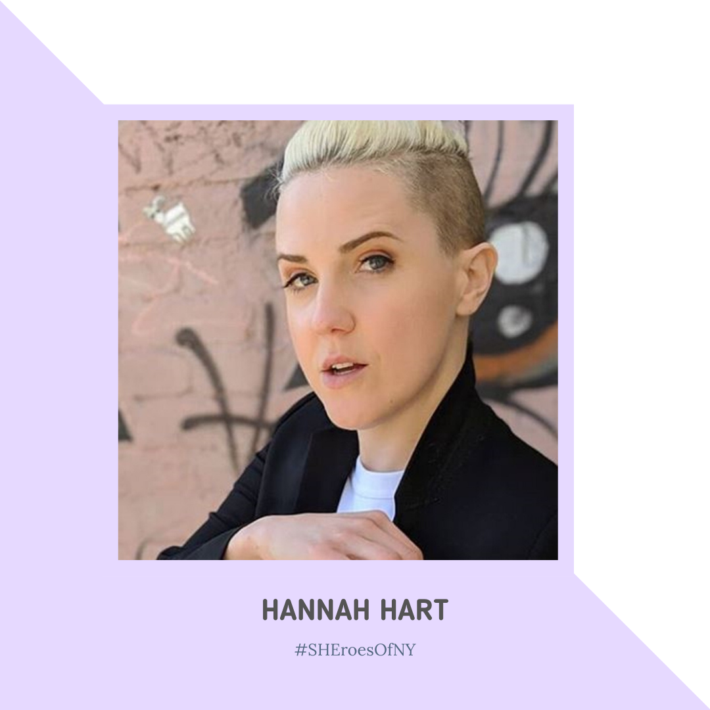

4/17 | Are you an artist who celebrates women and diversity? Submit your original work to us to be featured on our feed.
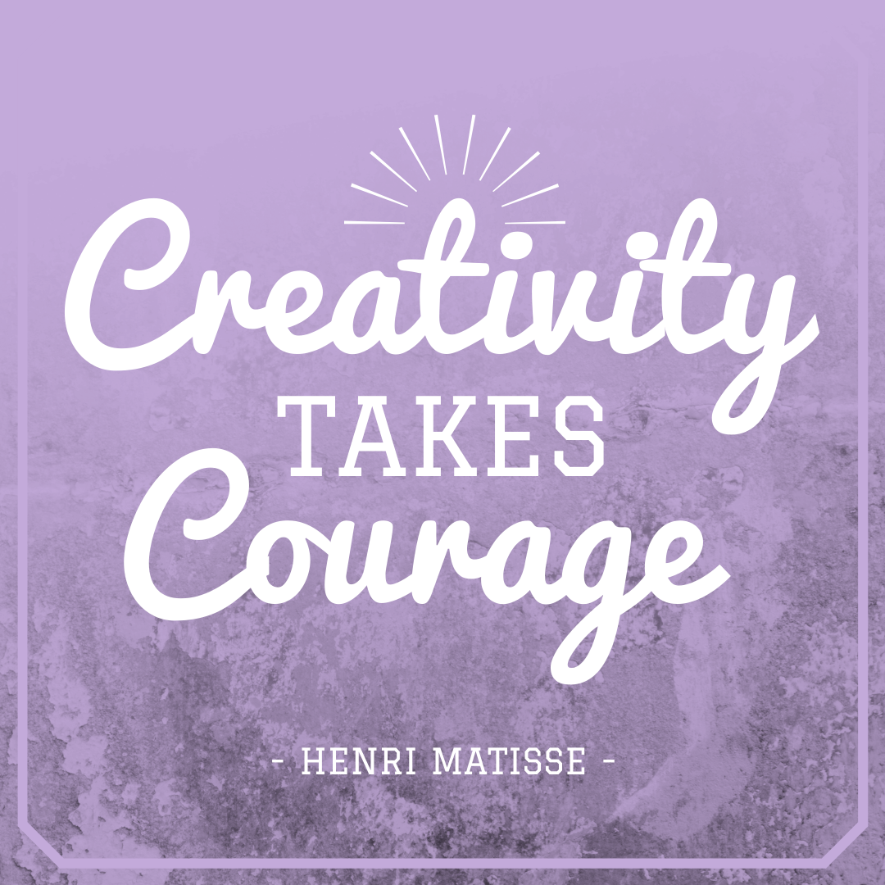

4/18 | Lean toward the light, we are so close to the other side <3
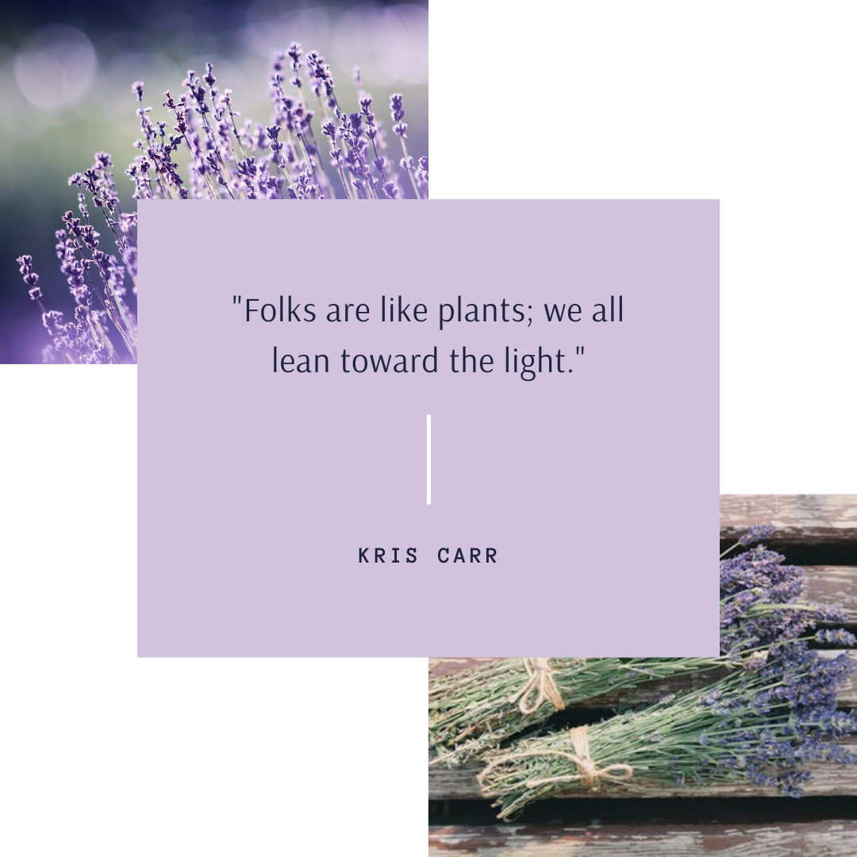

4/19 | "Human rights are women's rights, and women's rights are human rights." — Hillary Clinton
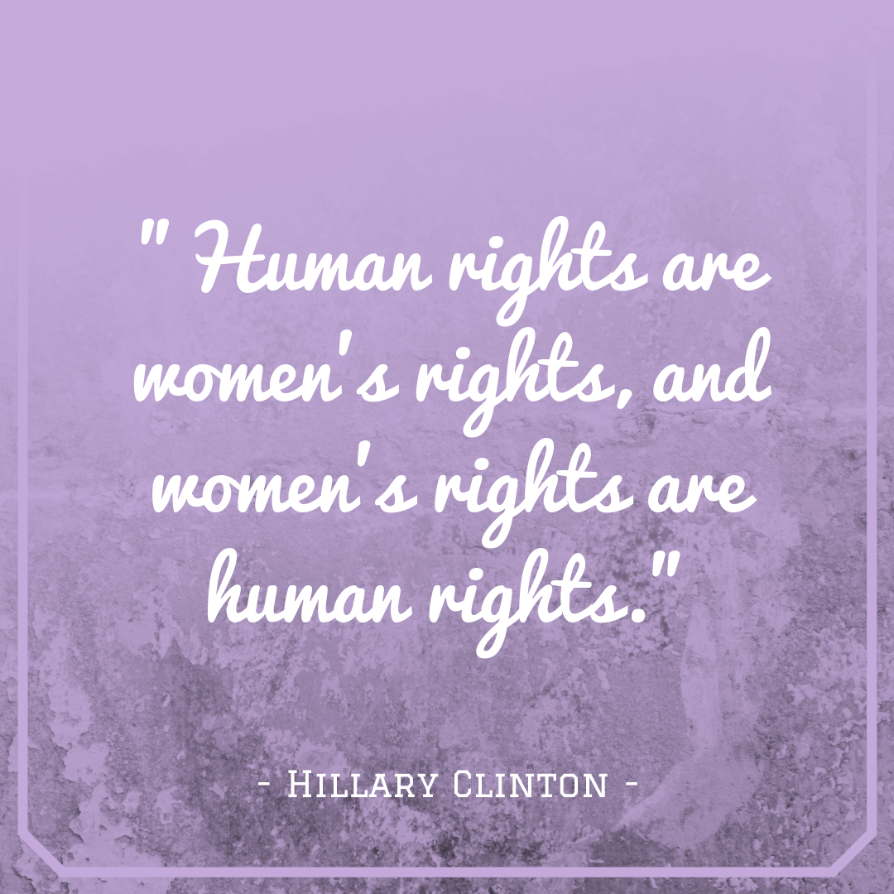

4/20 | "Women belong in all places where decisions are being made. It shouldn't be that women are the exception." — Ruth Bader Ginsburg
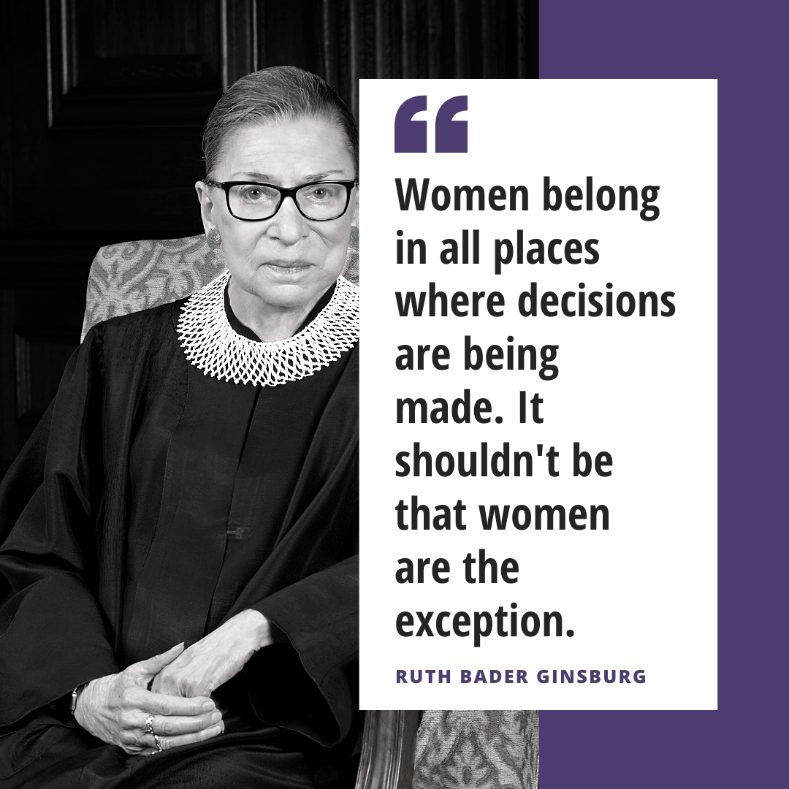

4/21 | Who runs the world #girls #grlpwr
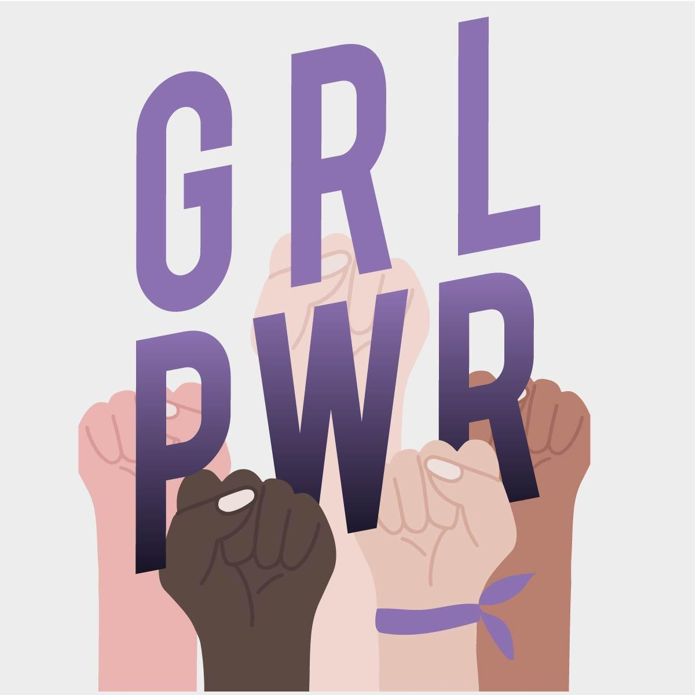

4/22 | Today we celebrate Ethel Smyth, who would have been 162 today. Ethel was an English composer as well as a member of the women’s suffrage movement. She composed music inspired by the movement and wrote the anthem of the movement entitled “The March of the Women”.
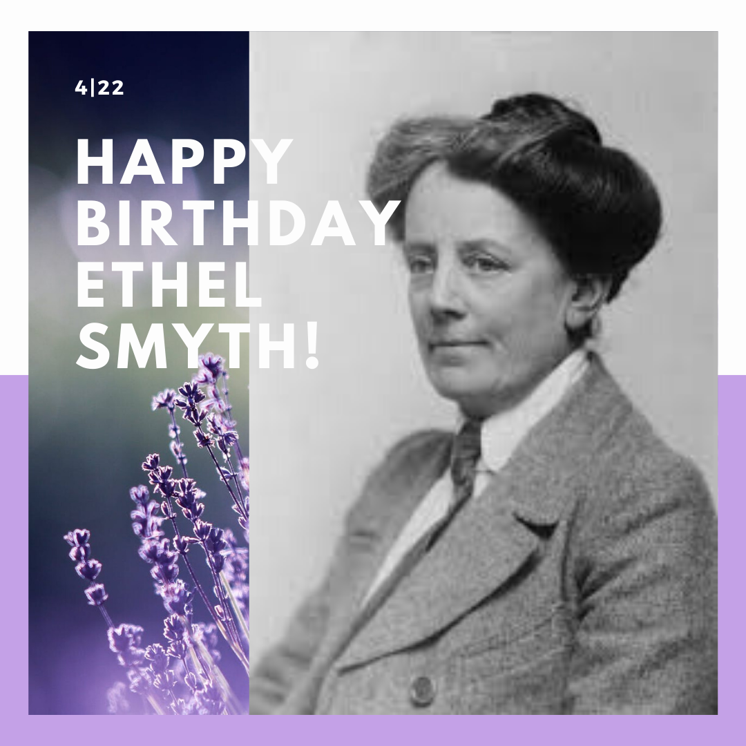

4/23 | “In the future, there will be no female leaders. There will just be leaders.” — Sheryl Sandberg
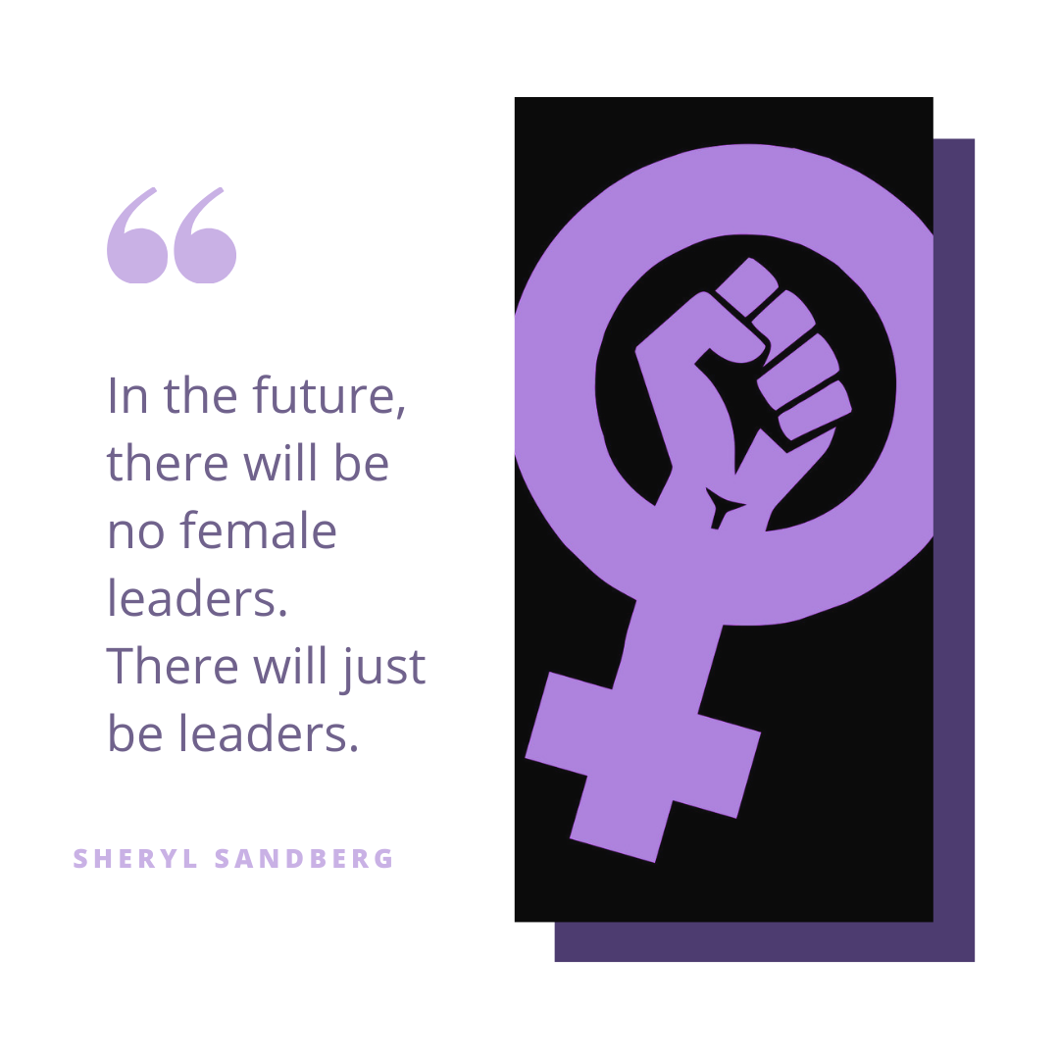
4/24 | If you know someone you would like to nominate to be featured as one of our #SHEroesOfNY, send us a DM with their story, name, and a picture of them.

SHEro Video

4/25 | "Suffrage is a common right of citizenship. Women have the right of suffrage. Logically it cannot be escaped." ― Victoria Woodhull
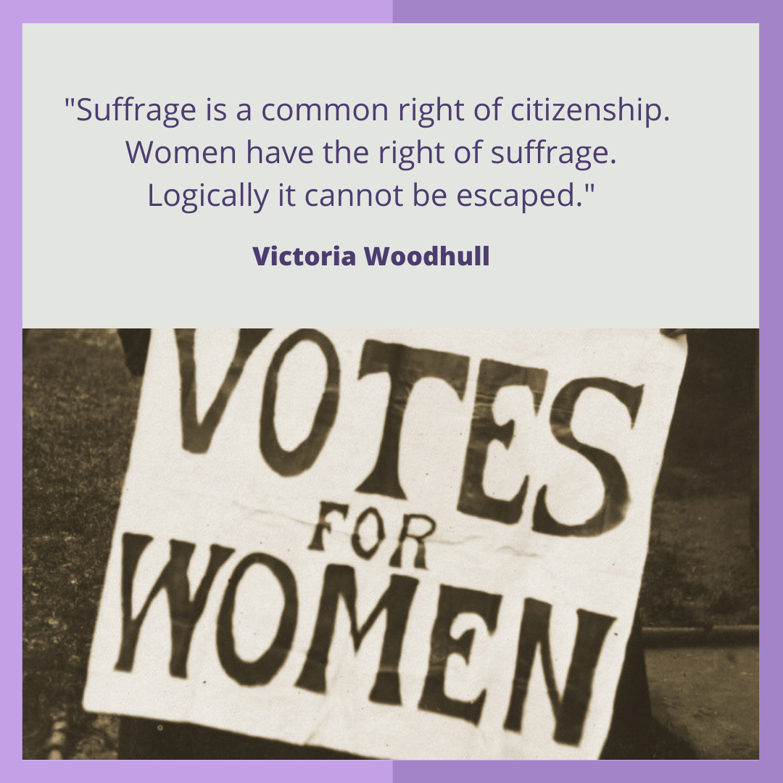

4/26 | Khrystyana Kazakova was a contestant on Cycle 24 of America's Next Top Model. She was eliminated in episode fifteen, coming in 3rd place. However, she did not let that bring her down. This resilient woman is the founder of the Real Catwalk which is a flash mob fashion show run in Times Square during NYFW, which has recently expanded to London. The Real Cat Walk embraces all women regardless of their shape, size, age, gender identity, ethnicity, or ability. She is a body positivity activist and a #SHEro to many.
.
If you know someone you would like to nominate to be featured as one of our #SHEroesOfNY, send us a DM with their story, name, and a picture of them.
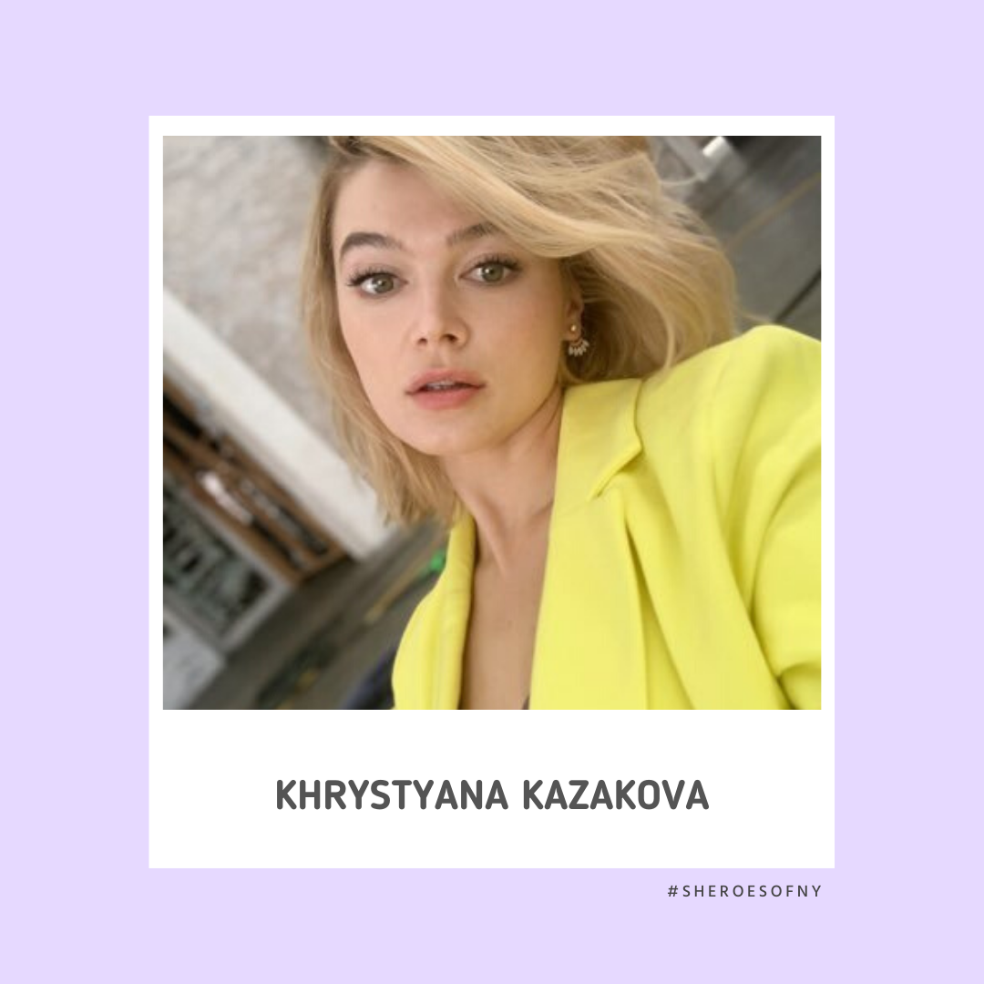

4/27 | “If you’re tired of complaining about the state of the country and government, get up and do something about it!!! #VOTE ... simple!!!” - Rihanna
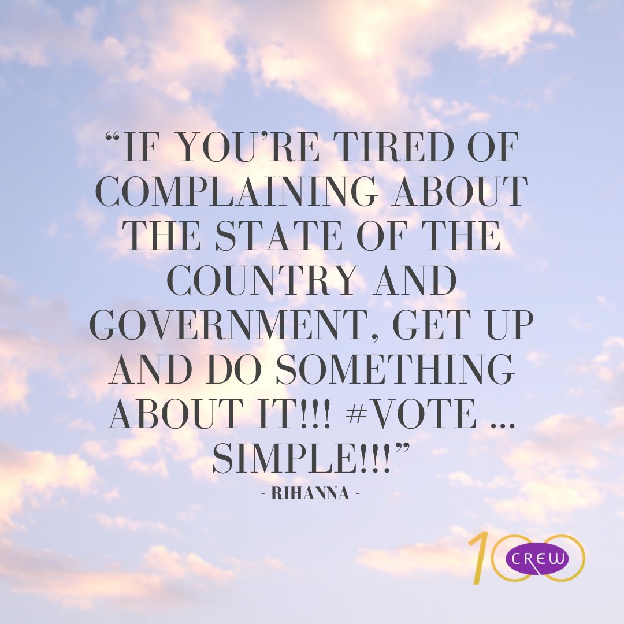

4/28 | Connie has dedicated her life to helping women regain their crowns as Queens to live with purpose not pain while on their sobriety journey. She has helped hundreds of women to destroy generational curses of alcohol abuse, use & dependency.
.
If you know someone you would like to nominate to be featured as one of our #SHEroesOfNY, send us a DM with their story, name, and a picture of them.
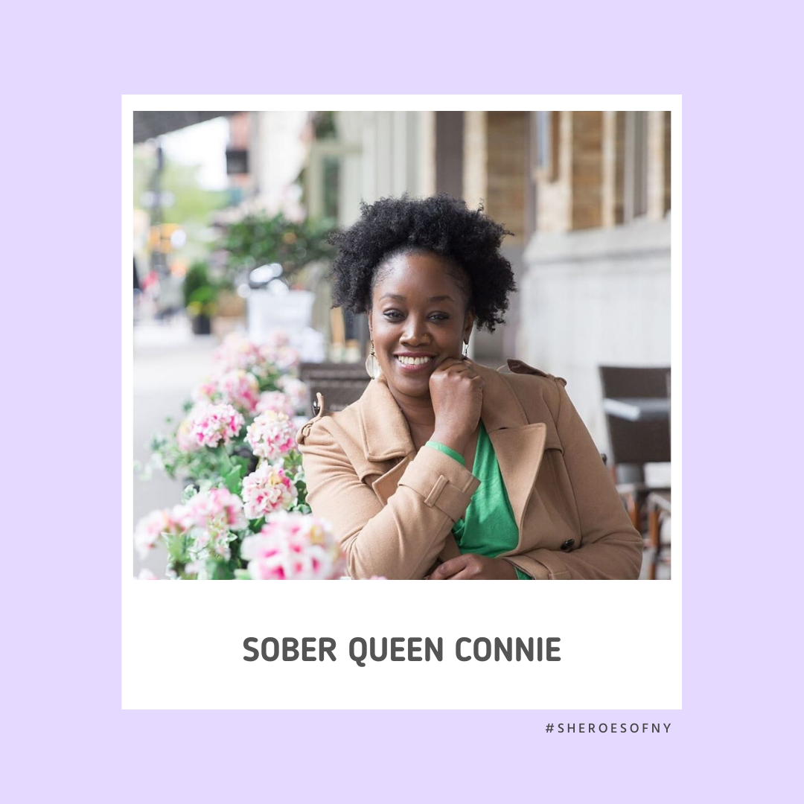

4/29 | "Feminism isn't about making women stronger. Women are already strong, it's about changing the way the world perceives that strength." — G.D. Anderson
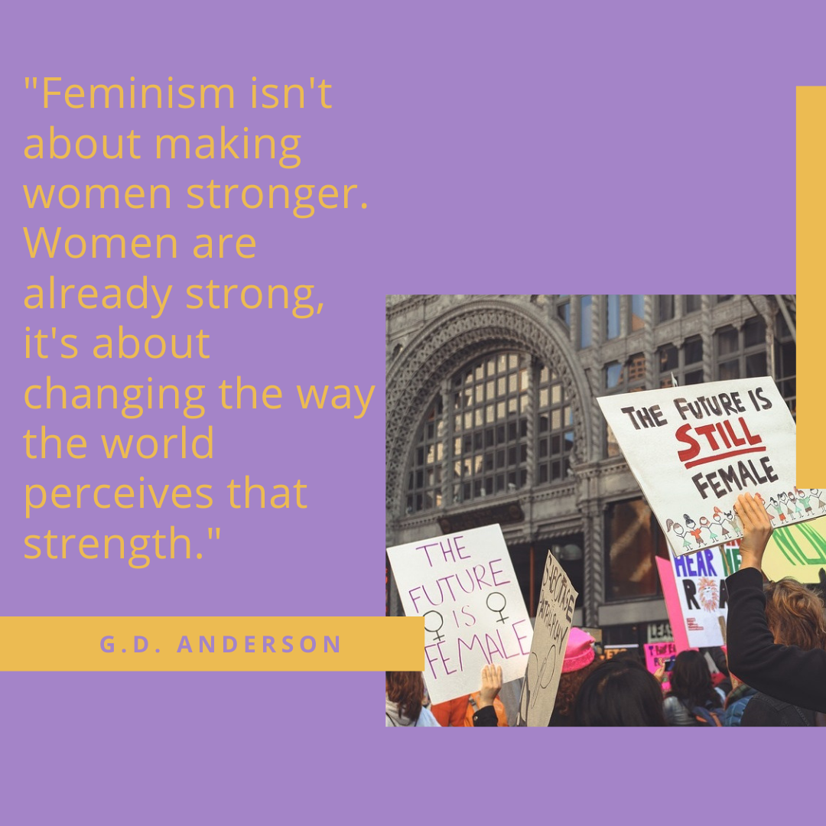

4/30 | We love featuring all of these strong women! If you know someone you would like to nominate to be featured as one of our #SHEroesOfNY, send us a DM with their story, name, and a picture of them.
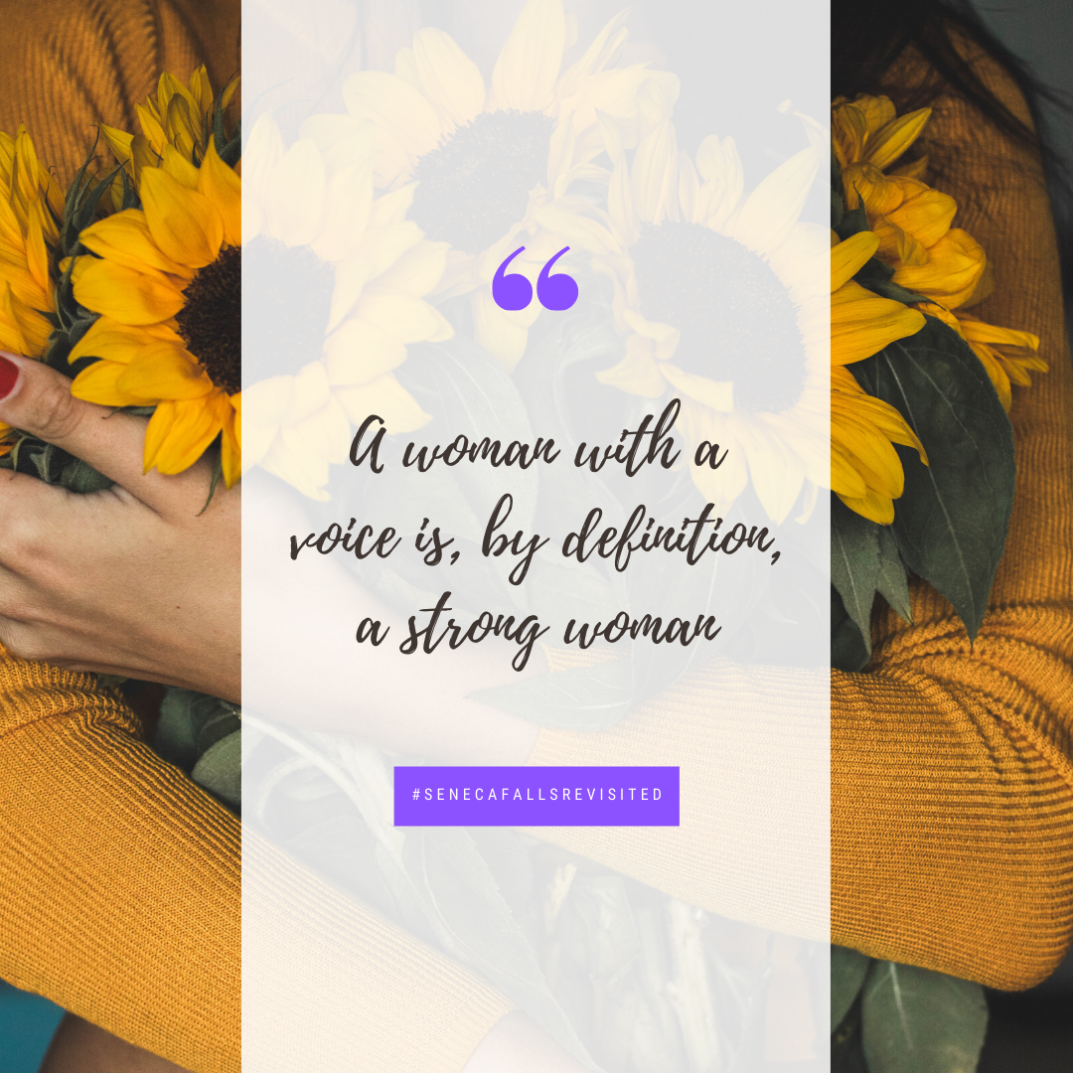

5/01 | "Well-behaved women seldom make history." — Laurel Thatcher Ulrich
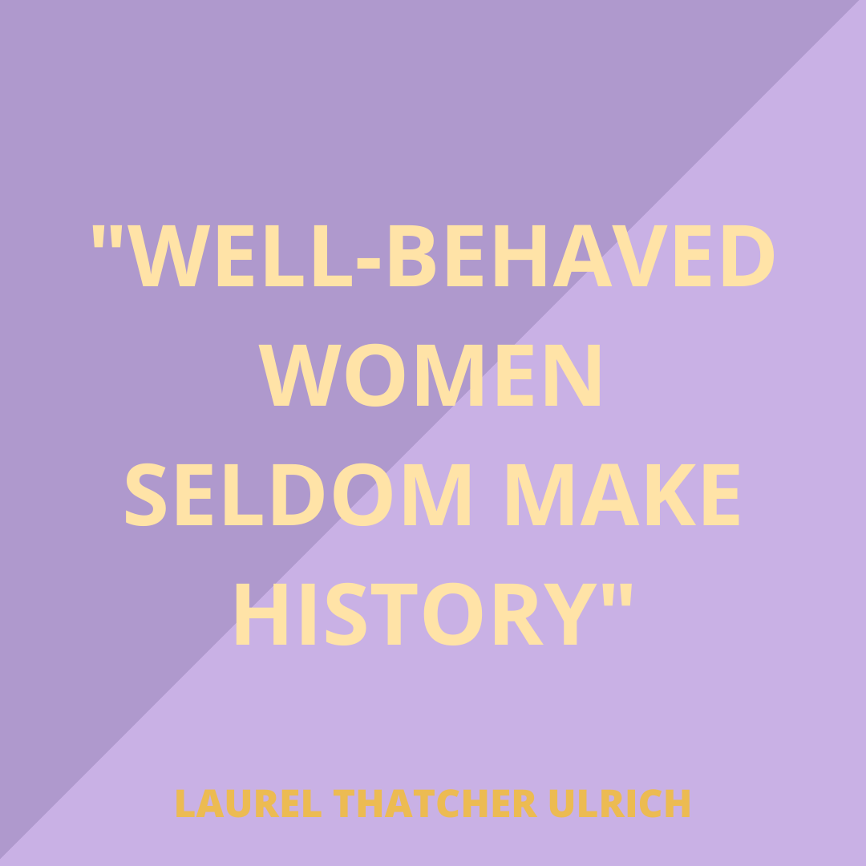

5/02 | "I’m feeling grateful for everyone before me who fought so hard to give us all the right to have a voice. We can’t voice our frustrations and complain about what’s wrong without voting and exercising our power to make it right. We need you. We all need each other, because when we are truly united we are unstoppable." - Beyonce
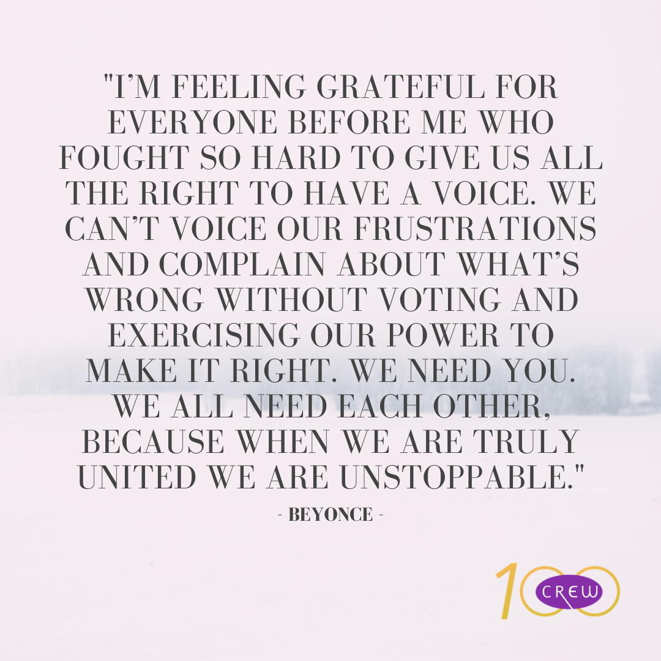

5/03 | One Week to the launch of CREW-TV! Our app is available through the Apple and Google Play stores, as well as through the CREW.com site, it will also be distributed on Apple TV and Roku. Best of all, our app will launch on Mother’s Day and is a great way to celebrate the strong women in your life.
One Week.mp4

5/04 | “I have never felt more exhilarated and moved than when I waited in that voting line and cast my vote. This is the time to stand up for what we believe is right and what we believe must change. We are loud, and our voices need to be heard." - Sailor Brinkley Cook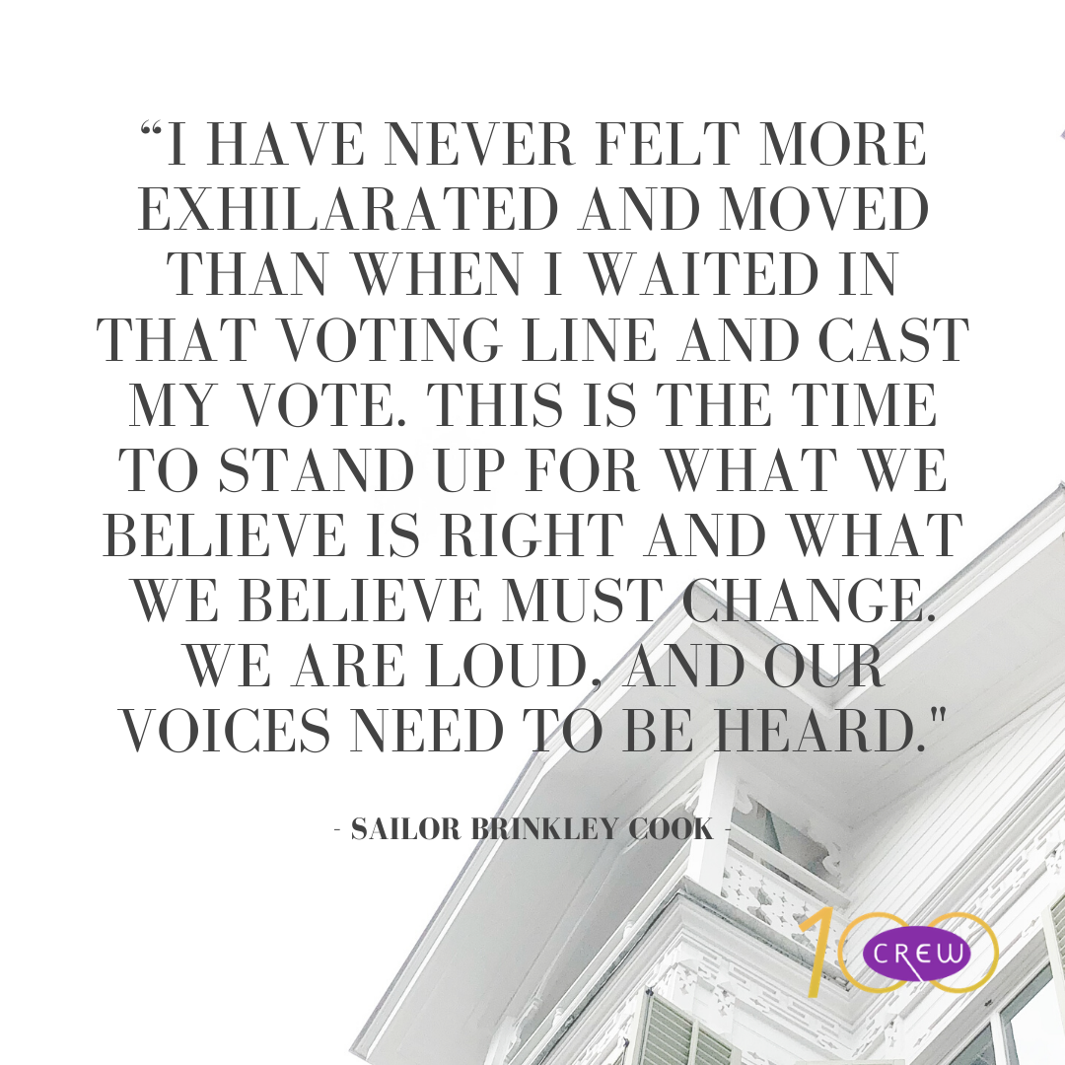

5/05 | Katerina won Teen Miss New York 2016. Since then, she has worked to build an initiative based on female empowerment with young girls in her community.

If you know someone you would like to nominate to be featured as one of our #SHEroesOfNY, send us a DM with their story, name, and a picture of them.
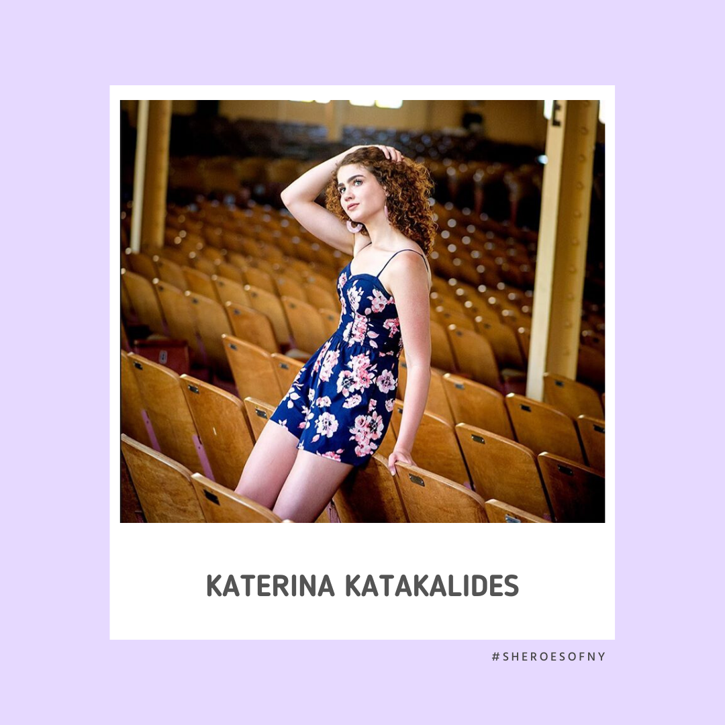

5/06 | "Forget conventionalisms; forget what the world thinks of you stepping out of your place; think your best thoughts, speak your best words, work your best works, looking to your own conscience for approval." ― Susan B Anthony
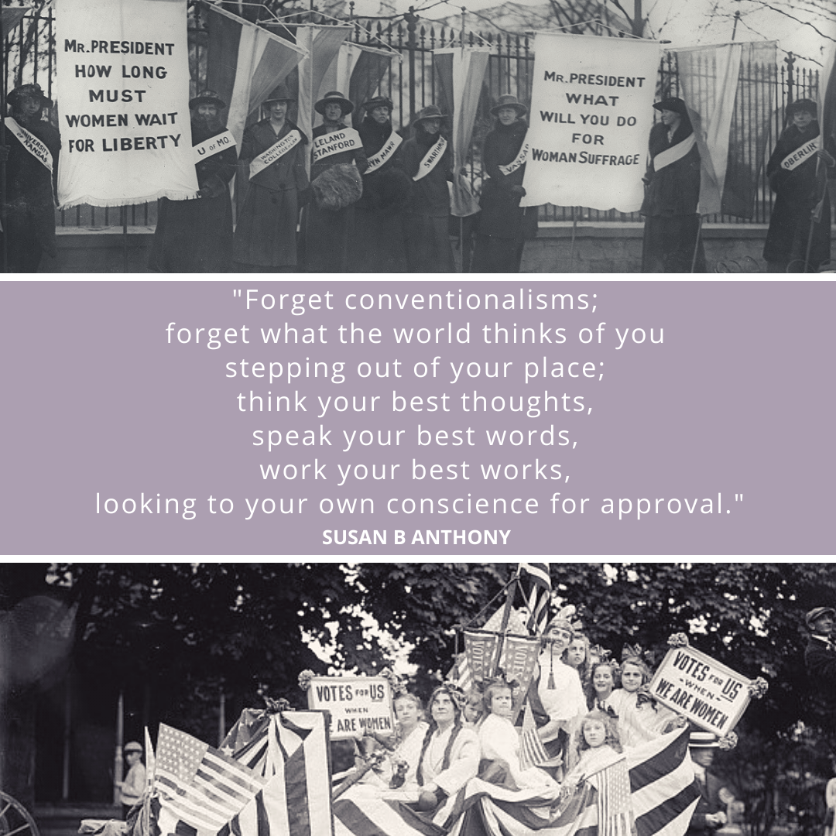

5/07 | Rep. Rosemary Brown recently led an initiative to protect the residents of her district from COVID-19. She worked with the legislators from Pennsylvania, New Jersey, and New York to shut down travel out of state through the buses that ferry residents of district 189 to the tristate area for work.
.
If you know someone you would like to nominate to be featured as one of our #SHEroesOfNY, send us a DM with their story, name, and a picture of them.
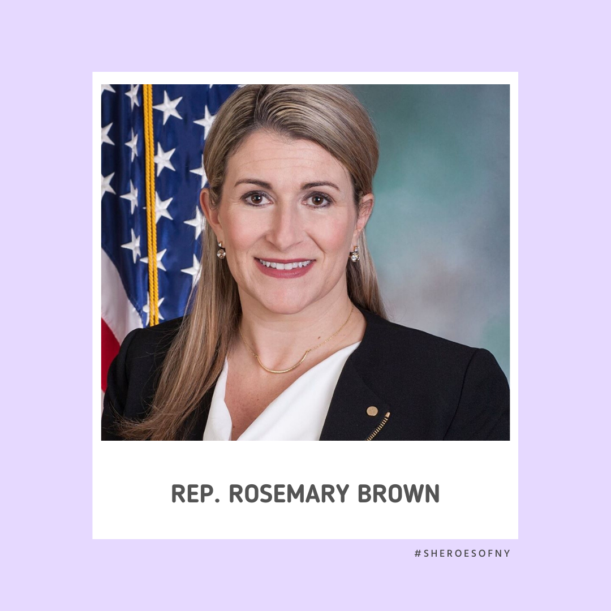

5/08 | CREW-TV launches in two days! The app is available through the Apple store & the Google Play store, as well as through the CREW.com site, it will also be distributed on Apple TV and Roku. Best of all, our app will launch on Mother’s Day and is a great way to celebrate the strong women in your life.
2Days.mp4

5/09 | What does being a #feminist mean to you?
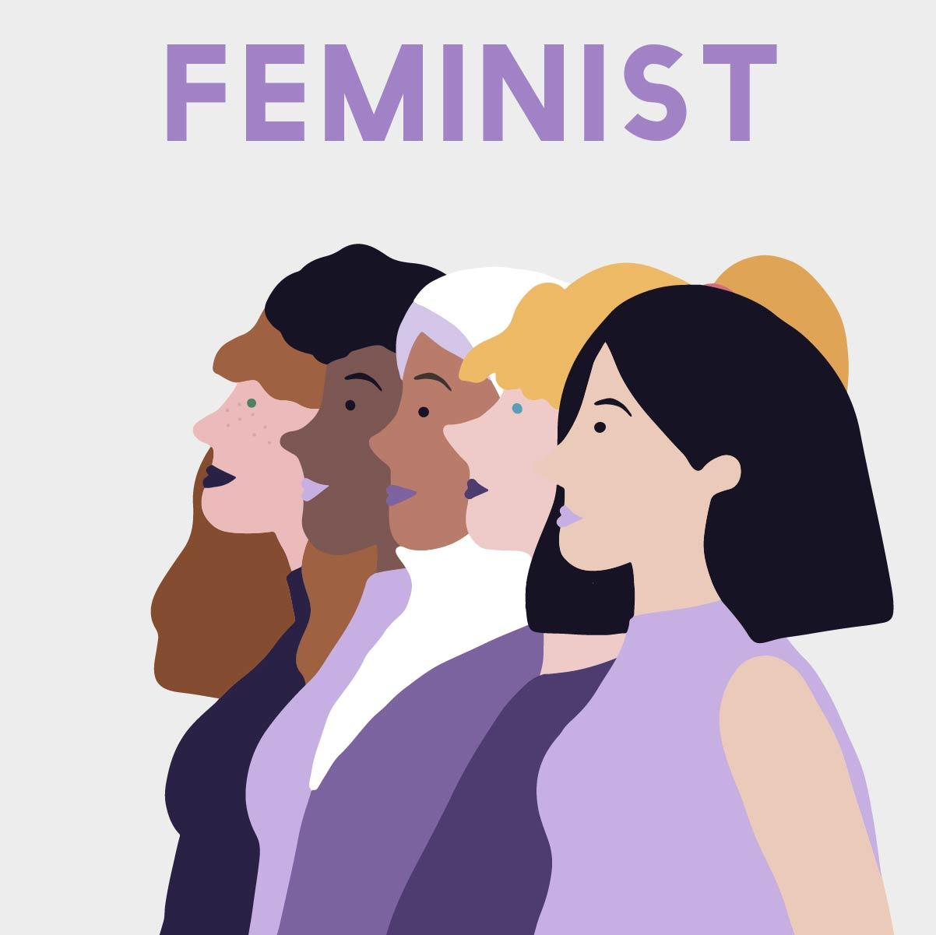

5/10 | Happy Mother’s Day to all Mothers of all kinds! Today, we are excited to announce in the honor of Mother’s Day that we are finally launching CREW-TV! CREW-TV is available through the Apple store & the Google Play store, as well as through the CREW.com site, it will also be distributed on Apple TV and Roku. Best of all, this app is free!
.
The channel will also have a subscription feature promotional for $99/year ($8.25/month). Those who choose to subscribe will receive the conference for free as well as any other special programming we will host. Otherwise the 3-day conference will be available for $59 per viewer, group rate at $500 for the conference (group homes, nursing homes, youth hostels, etc)
.
Otherwise by July there will be more of the “on demand” content as you know we are currently shopping for content.
.
The focus of the channel is as follows:
• Women’s General Interest
• Women’s Advocacy
• Civic Engagement
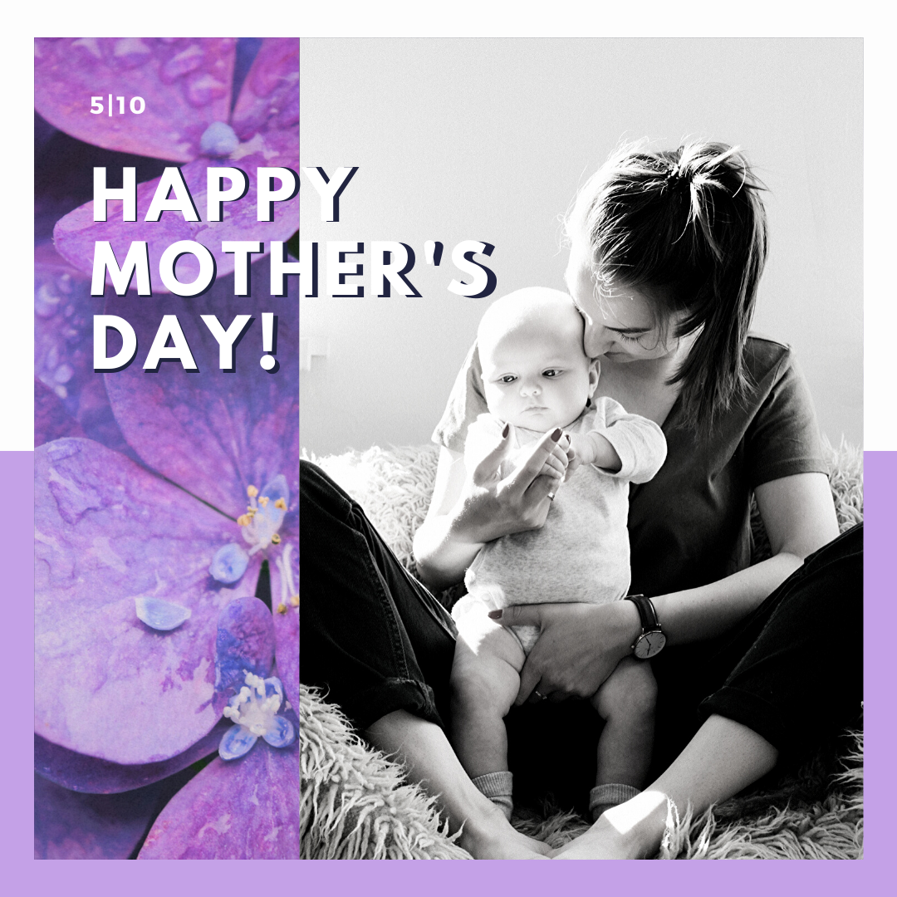

5/11 | "I do know one thing about me: I don’t measure myself by others’ expectations or let others define my worth." — Sonia Sotomayor
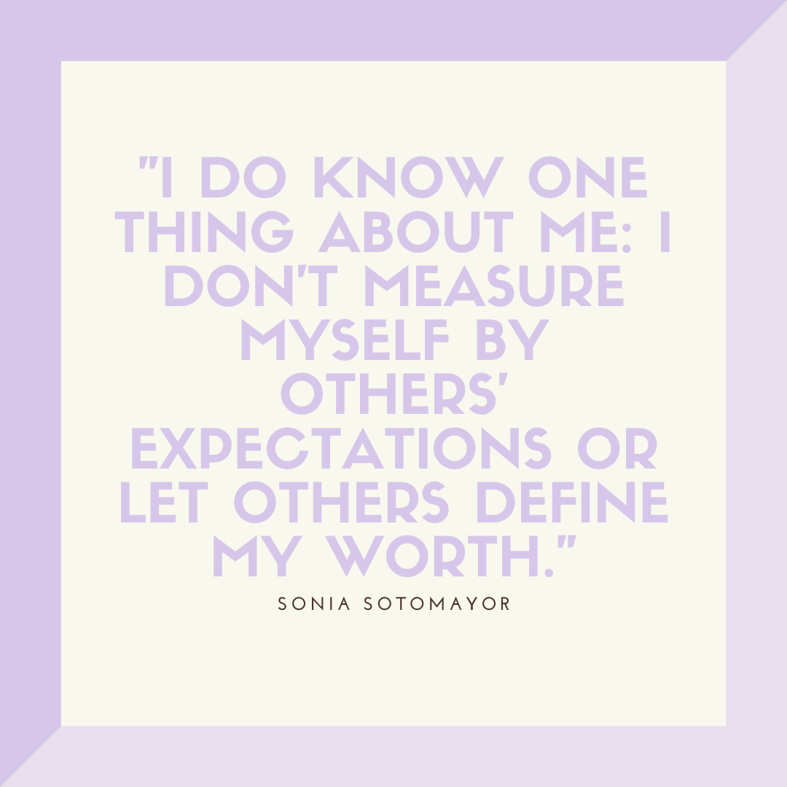

5/12 | "We realize the importance of our voices only when we are silenced." — Malala Yousafzai
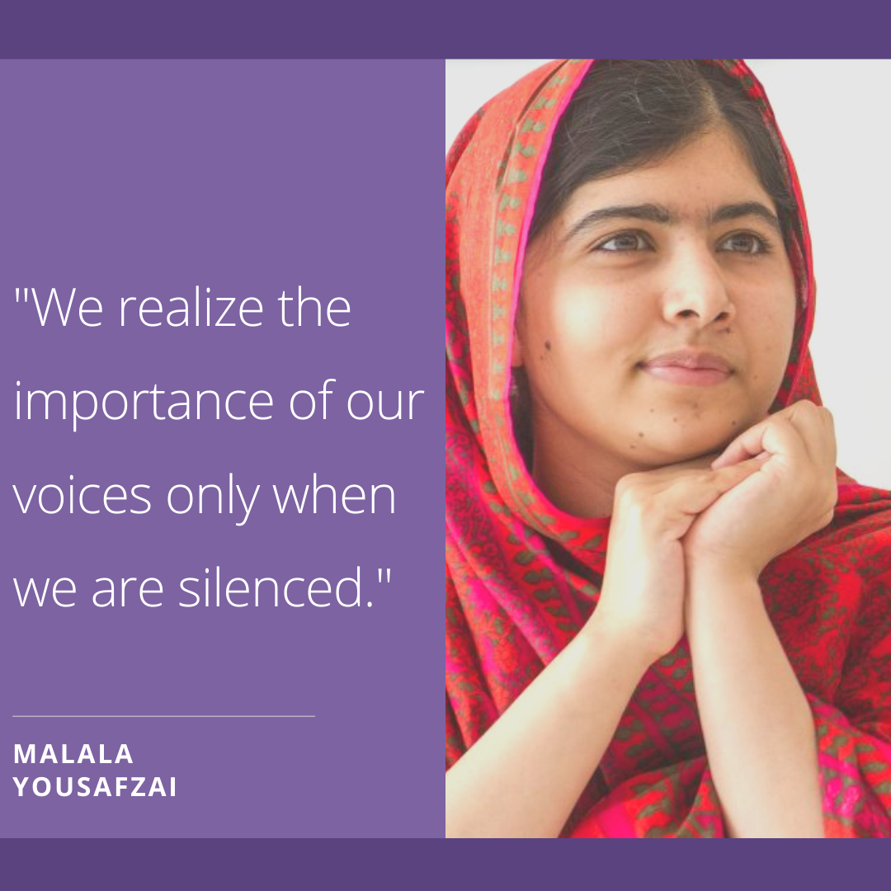

5/13 | “The future belongs to those who believe in the beauty of their dreams.” ― Eleanor Roosevelt
